CHAPTER 14
Monopoly and Antitrust Policy
- Chapter Summary
- Learning Objectives
- Chapter Outline
Teaching Tips/Topics for Discussion
- Solved Problems
- Solutions to Review Questions and Problems and Applications

1. Chapter Summary
A monopoly is a firm that is the only seller of a good or service that does not have a close substitute. For a monopoly to exist barriers to entering the market must be so high that no other firms can enter. These entry barriers result from: government blocking the entry of more than one firm into a market; control over a material necessary to produce a product; important network externalities; and economies of scale so large that one firm has a natural monopoly.
A monopoly firm maximizes profit by producing the level of output where marginal revenue equals marginal cost. A monopoly firm’s demand curve is the market demand curve. If the monopolist’s price exceeds its average total cost at the output where marginal revenue equals marginal cost, it will earn an economic profit. Because of high entry barriers new firms will not be able to enter the market so if other things remain the same, the firm will be able to continue to earn economic profits, even in the long run. A monopolist will produce less and charge a higher price than would a perfectly competitive industry producing the same good. The monopolist’s profit-maximizing price exceeds marginal cost. Thus the monopoly equilibrium is neither productively efficient nor allocatively efficient.
The first important law regulating monopolies in the United States was the Sherman Act of 1890 which targeted firms that combined to forms trusts. Other acts were passed in the 20th century to regulate behavior not addressed in the Sherman Act. The Department of Justice and the Federal Trade Commission have developed guidelines to evaluate proposed mergers between firms. The guidelines have three main parts: market definition, measure of concentration and merger standards. It is up to the firms that propose to merge to document the efficiencies that would result from their merger.
It is typical for state or local regulatory commissions to set prices for natural monopolies. Most regulators allow owners of monopoly firms to earn a normal rate of return on their investment.

2. Learning Objectives
Students should be able to:
- Define monopoly.
- Explain the four main reasons monopolies arise.
- Explain how a monopoly chooses price and output.
- Use a graph to illustrate how monopoly affects economic surplus.
- Discuss government polices toward monopoly.

3. Chapter Outline
Time Warner Rules Manhattan
1. Time Warner Cable, a division of the Time Warner Company, operates cable televisions systems in the U.S. As the only provider of cable television in Manhattan it has a monopoly in this market. There are few monopoly firms in the U.S. because when a firm earns an economic profit other firms have an incentive to enter the market.
►Teaching tips: The introduction and “An Inside Look” at the end of the chapter discuss monopoly in the cable television industry. This market is also used to illustrate monopoly in Figures 14-2, 14-3, “Solved Problem” 14-2 and “Don’t Let This Happen to You!” In addition, “Problems and Applications” numbers 3, 14, 15, 16 are related to these features. Ask your students if they have cable in their own homes and if they have other options to choose from for television programming.
Is Any Firm Ever Really a Monopoly?
1. A monopoly is a firm that is the only seller of a good or service that does not have a close substitute.
- A narrow definition of monopoly is that a firm is a monopoly if it can ignore the actions of other firms.
- A broad definition of monopoly is that a firm is a monopoly if it can retain economic profits in the long run.
►Teaching tips: “Making the Connection” 14-1 considers the meaning of the term “close substitute” using the example of Microsoft’s Xbox video-game console and the Sony PlayStation 2. Contrary to their prior belief, Microsoft executives discovered the two products were substitutes.
Where Do Monopolies Come From?
1. A monopoly requires that barriers to entry into the market must be so high that no other firms can enter. Entry barriers include:
- Government blocks the entry of more than one firm into a market.
  - Granting a patent or copyright gives an individual or firm the exclusive right to produce a product. A patent is the exclusive right to a product for a period of 20 years from the date the product was invented.
  - U.S. copyright law gives the creator of a book, film, or piece of music the exclusive right to use the creation during the creator’s lifetime.
  - Granting a firm a public franchise makes it the exclusive legal provider of a good or service. A public franchise is a designation by the government that a firm is the only legal provider of a good or service.
- One firm has control of a key raw material necessary to produce a good.
- There are important network externalities in supplying the good or service.
  - Network externalities exist in the consumption of a product if the value of the product increases with the number of people who are using it.
  - Some economists argue that network externalities are a barrier to entry but other economists believe dominant positions by firms reflect their efficiency in satisfying consumer preferences.
- Economies of scale are so large that one firm has a natural monopoly.
  - A natural monopoly is a situation in which economies of scale are so large that one firm can supply the entire market at a lower average total cost than can two or more firms.
►Teaching tips: “Making the Connection” 14-2 and 14-3 describe the source of monopoly for firms in two different markets. “Solved Problem” 14-1 describes the long-run average total cost curve of a natural monopoly. “Problems and Applications” 13 and 14 are related to these features.
How Does a Monopoly Choose Price and Output
1. A monopoly maximizes profit by producing the level of output where marginal revenue equals marginal cost.
- The monopoly’s demand curve is the market demand curve for the product.
- The monopolist is a price maker. It faces a downward sloping demand curve and its marginal revenue is less than its price.
- If the monopolist earns an economic profit new firms will not be able to enter the market. Therefore, long-run economic profits can be earned.
►Teaching tips: Assign “Solved Problem” 14-2 to give students a clear understanding of a monopoly firm’s profit maximizing price and output. “Problems and Applications” 13 and 14 focus on similar topics. “Don’t Let This Happen To You!” and “Problems and Applications” 15 and 16 warn students that charging a higher price is not always profitable. Professional sports leagues such as Major League Baseball and the National Football League have been effectively exempt from antitrust laws. These leagues can negotiate television contracts for all of their teams and they restrict the number of franchises. In other words, they act as monopolists. But monopoly power does not guarantee a profit to each team. As is true in other industries, poor management or weak consumer demand can lead to economic losses; The Montreal Expos baseball franchise is one example of this. But successful franchises such as the Los Angeles Dodgers or the Kansas City Chiefs need not fear the entry of new teams into their markets.
Does Monopoly Reduce Economic Efficiency?
1. Compared to equilibrium in a perfectly competitive market, which results in the maximum amount of economic surplus, a monopoly will produce less and charge a higher price.
- The monopoly firm’s price is higher and its output is lower than the efficient levels of price and output.
- Many firms that are not monopolies have some market power. Market power is the ability of a firm to charge a price greater than marginal cost.
- The loss of economic efficiency due to market power in the United States is small, probably less than 1 percent of total production.
- Some economists claim that the economy may benefit from firms having market power.
- Firms with market power are more likely than more competitive firms to earn profits that can be used to conduct research and development and introduce new products.
►Teaching tips: The graphs in Figures 14-4 and 14-5 compare economic efficiency under conditions of monopoly and perfect competition. Although small firms are the source of invention and innovation, firms with market power are better able to afford product development. Product development involves taking a new product or process, perhaps one developed by a small firm, and making it commercially successful. The failure rate for product development can be very high, over 50 percent in some industries, and it may take several years for new products to become profitable.
Government Policy toward Monopoly
1. Because monopolies reduce consumer welfare and efficiency most governments regulate their behavior.
- Collusion refers to an agreement among firms to charge the same price, or to otherwise not compete.
- Antitrust laws are laws aimed at eliminating collusion and promoting competition among firms.
- Governments regulate firms that are natural monopolies, often by controlling their prices.
- The Sherman Act of 1890 was the first important law regulating monopolies in the U.S.
- The Clayton Act of 1914 made a merger illegal if its effect was to lessen competition or tended to create a monopoly.
2. The federal government regulates business mergers because mergers can result in firms gaining market power. Horizontal mergers are between firms in the same industry. Vertical mergers are between firms at different stages of production of a good.
A. It is important to define the appropriate market when evaluating a proposed merger.
B The newly merged firm may be more efficient than the merging firms were individually.
C. The Department of Justice and the Federal Trade Commission developed merger guidelines in 1982.
D. The merger guidelines have three main parts.
      - Market definition
      - Measure of concentration
      - Merger standards
E. Merging firms must substantiate efficiency claims that would result from their proposed merger.
3. Local or state regulatory commissions usually set prices for natural monopolies.
- Regulators should require that the monopoly charge a price equal to marginal cost to achieve economic efficiency if marginal cost is greater than average total cost.
- If the monopoly’s marginal cost is less than its average total cost most regulators will allow the monopoly to set a price equal to its average total cost so that the owners of the monopoly can earn a normal return on their investment.
►Teaching tips: Antitrust laws and regulation are the themes for “Problems and Applications” numbers 20 through 27. The actual regulation of natural monopolies is more complicated than the guidelines “set price equal to marginal cost” or “set price equal to average total cost” suggest. Regulatory commissions often recruit their members from the companies they regulate; although these individuals have valuable knowledge regarding the regulated firm they may be biased toward the firm’s positions rather than the consumers whose interests they are supposed to represent. Other regulators may be biased against the firms they regulate. It is difficult to select commission members who are both knowledgeable and unbiased. Another problem is that allowing a firm to earn a normal profit may give it less incentive to reduce its cost than if it were unregulated. The firm would not earn higher profits from any cost-cutting actions and the commission would be willing to allow a price increase if higher average total costs could be documented.

4. Solved Problems
Chapter 14 includes two Solved Problems to support learning objectives 2 (Explain the four main reasons monopolies arise) and 3 (Explain how a monopoly chooses a price and output). The following Solved Problems support this chapter’s three other learning objectives.

Solved Problem 14-3 Supports learning objective 1: Define monopoly

Is the Cable Television Monopoly Over?
In June 2005 executives of Cablevision Systems Corp. offered to buy all public shares of the company for $7.9 billion. Cablevision, which has had a virtual monopoly on cable television service in Long Island and parts of New York City, was feeling the competitive heat from regulatory reform and new technology. The Satellite Home Viewer Improvement Act of 1999 allowed Digital Satellite Systems (DBS) to carry local broadcast signals back to their home markets. An aggressive campaign by DBS systems, such as DirecTV, to lure cable customers with low prices for equipment and service resulted in an increase in their national market share from 7 to 17 percent between 1998 and 2003.

But Cablevision had more to worry about. So-called Baby Bell phone companies were preparing to invade cable’s turf by offering not only digital television programming, but high-speed Internet access and phone service. Ironically, the Baby Bell companies were formed after the breakup AT&T which for years had a monopoly on local and long-distance telephone service. One of the Baby Bells is Verizon, which was awaiting local government approval to offer phone service in New York when Cablevision’s announcement of its offer to go private was made. Verizon officials hinted they will offer more channels for less money than cable companies can charge. Industry analysts believe that Cablevision planned to invest more money in customer service and technology, moves that would lower short-run profits and share price if it were to remain a publicly-owned company.

Sources: “Cable System’s New Weapon In Phone Battle: Going Private” by Peter Grant, Wall Street Journal,” June 21, 2005.
“Cable TV Suffers From High Rate Increases, Lower Satisfaction,” by Robyn Greenspan, Hardware. August 21, 2003.

- What is the definition of monopoly?
- Are cable television companies such as Cablevision monopolies?

Solving the Problem:
Step 1: Review the chapter material. Since this problem is about the definition of monopoly you may want to review the section “Is Any Firm Ever Really a Monopoly?” which begins on page 444 in the textbook.
Step 2: Answer question (a). A monopoly is the only seller of a good or service that does not have a close substitute.
Step 3: Answer question (b). The key to identifying a firm as a monopoly is determining whether the good or service it offers has close substitutes. Applying a narrow definition of monopoly, Cablevision is a monopoly if one can demonstrate Cablevision can ignore other firms’ prices. Although this was true at one time, Cablevision cannot ignore the prices charged by DBS companies and other competitors now that they can offer customers comparable services. A broader definition of monopoly would consider Cablevision to be a monopoly, even if there are substitutes for its service, if it can earn long- run economic profits. Using this definition is it too early to state that Cablevision and other cable television companies have lost their monopoly status. But it will be increasingly difficult for cable companies to earn economic profits as more firms offer similar services in the future.

Solved Problem 14-4 Supports learning objective 4: Use a graph to illustrate how monopoly affects economic surplus.

Computing the Difference in Economic Surplus between Perfect Competition and Monopoly
The graph shown below illustrates a monopoly market where the firm maximizes profit by setting price of $25 at the quantity where marginal revenue (MR) equals marginal cost (MC). The profit maximizing quantity is 10,000. If this market were perfectly competitive, the price would equal marginal cost; therefore, the equilibrium price and quantity would be $20 and 14,000, respectively.

- Compute the difference in consumer surplus between the equilibrium under monopoly and perfect competition.
- Compute the difference in producer surplus between the equilibrium under monopoly and perfect competition.
- Compute the difference in economic surplus under monopoly and perfect competition.

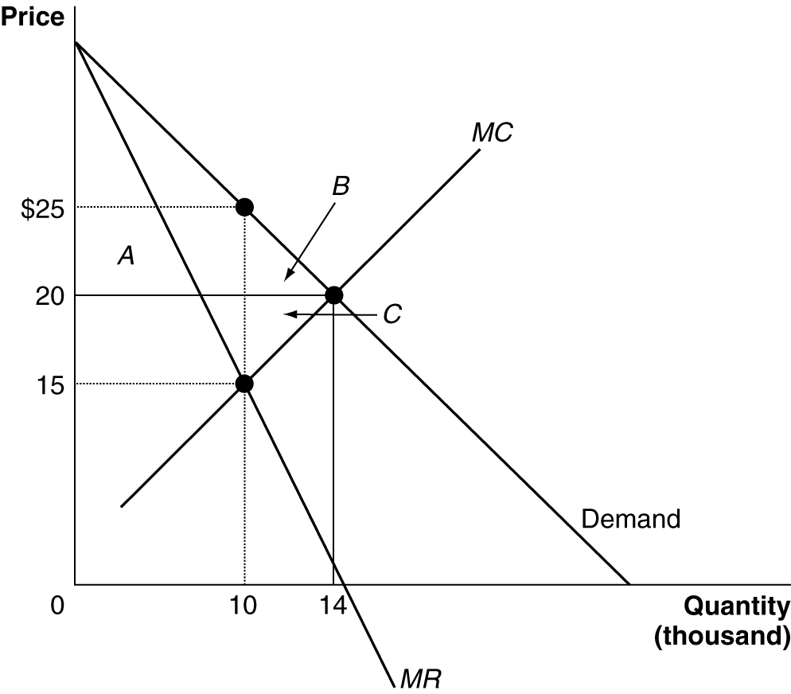

Solving the Problem:
Step 1: Review the chapter material. You may want to review “Does Monopoly Reduce Economic Efficiency?” since this problem refers to the material in this section of the textbook. The section begins on page 455.
Step 2: Answer question (a). Monopoly results in a loss of consumer surplus equal to sum of areas A and B in the graph. Area A equals $50,000 [($25 - $20) x 10,000]. Area B equals $10,000 [1/2 x ($25-$20) x (14,000 – 10,000)]. Therefore, there is a loss of consumer surplus equal to $60,000 from monopoly as compared to the perfectly competitive equilibrium.
Step 3: Answer question (b). Area A minus area C is the gain in producer surplus that results from the monopoly price of $25 rather than the perfectly competitive price $20. Area A equals $50,000. Area C equals $10,000 [1/2 x ($20 - $15) x (14,000 – 10,000)]. Area A minus area C equals $40,000.
Step 4: Answer question (c). Economic surplus is the total of consumer and producer surplus. Since area A is a transfer of surplus from consumers to producers there is a net loss of economic surplus ( a “deadweight loss”) equal to area B ($10,000) plus area C ($10,000) or $20,000.

Solved Problem 14-5 Supports learning objective 5: Discuss government policies toward monopoly.

The Art of Collusion
Sotheby’s and Christie’s account for about 90 percent of the international art auction market. Auction houses charge commissions to the owners of paintings being auctioned. By the early 1990s Sotheby’s and Christie’s were in fierce competition for the best Old Master, Impressionist, and modern paintings. They offered sellers guaranteed prices, reduced commissions, free shipping and insurance and even donations to their favorite charities. Such aggressive tactics lowered the firms’ profits; as a result of a guarantee given to the owner of one paining, Sotheby lost $9.5 million when the painting failed to sell at auction.

In 1993 Sir Anthony Tenant, the British chairman of Christie’s, and A. Alfred Taubman, the American chairman of Sotheby’s, decided to collude by agreeing to: charge similar commissions, not to hire each other’s employees, and not to speak badly of each other to clients. The deal was revealed to the U.S. Justice Department in 1999 when an employee fired by Christie’s turned over records implicating the two auction house chairmen. Taubman and Tenant were both indicted and both firms were fined and paid $256 million to settle private lawsuits filed by their clients.

Sources: Carol Vogel and Ralph Blumenthal, “Memos Point to Ties Between Auction Houses,” New York Times, May 25, 2001; Carol Vogel and Ralph Blumenthal, “At Auction Trial, a Cameo for a Johns Painting,” New York Times , November 21, 2001; Carol Vogel and Ralph Blumenthal,“Ex-Chief of Sotheby’s is Convicted of Price Fixing,” New York Times, December 6, 2001.

Which antitrust laws did the chairmen of Sotheby’s and Christie’s violate when they agreed to collude?

Solving the Problem:
Step 1: Review the chapter material. This problem refers to the material from “Government Policy Toward Monopoly”, so you may want read this section of the textbook which begins on page 458.
Step 2: Which antitrust laws did the chairmen of Sotheby’s and Christie’s violate when they agreed to collude? The Sherman Act of 1890 prohibits price fixing and collusion, actions for which the chairmen of Sotheby’s and Christie’s were prosecuted. Taubman was convicted and sentenced to one year and a day in prison and fined $7.5 million. Since Tenant was a British citizen he refused to travel to New York to stand trial. Under British law he could not be extradited.

5. Solutions to Review Questions and Problems and Applications

Answers to Thinking Critically Questions

1. One reason that a local government might give only one cable television firm a license to enter its market is that the government desires to capture some of the monopoly profits from the firm in the form of a franchise fee or other concessions. This practice might benefit some city residents, whose tax rates might fall, but it will harm many city residents who must pay higher prices for cable TV. Another reason that a government might give a monopoly franchise is that no firm may be willing to enter without such a guarantee, fearing that subsequent entry by other firms will give the first entrant an unacceptably low profit rate. A third reason is that perhaps economies of scale are so large that one firm can supply the entire market at a lower average cost than can two or more firms (natural monopoly).

2. If you were seeking the highest profit, you probably wouldn’t want to open up your network. Although you would be able to charge other firms for using your network, allowing them into the network would allow them to steal your customers away.

Answers to Review Questions

1. A monopoly is the only seller of a good or service that does not have a close substitute.

2. The most important ways a firm becomes a monopoly are when 1) government blocks the entry of other firms into the market, 2) the firm has control of a key raw material, 3) there are important network externalities in supplying the product, and 4) economies of scale are so large that one firm has a natural monopoly.

3. A natural monopoly arises when one firm can supply the entire market at a lower average total cost than can two or more firms. In cases like this the firm doesn’t need a special law or strategy to become a monopoly.

4. The government grants patents because it hopes that in the long run society will be better off. The potential profits to be earned by the temporary monopoly will encourage more rapid technological progress. Competition still exists, but it focuses more on coming up with new products and processes.

5. A public franchise is a firm which the government designates as the only legal provider of a good or service. It is doubtful that most public franchises are natural monopolies. If they were, they wouldn’t need the government to restrict their competitors.

6. The monopolist’s demand curve is the market demand curve. The marginal revenue curve is derived from the demand curve. For a linear demand curve, the marginal revenue will hit the vertical axis at the same point as the demand curve and be twice as steep.

7.

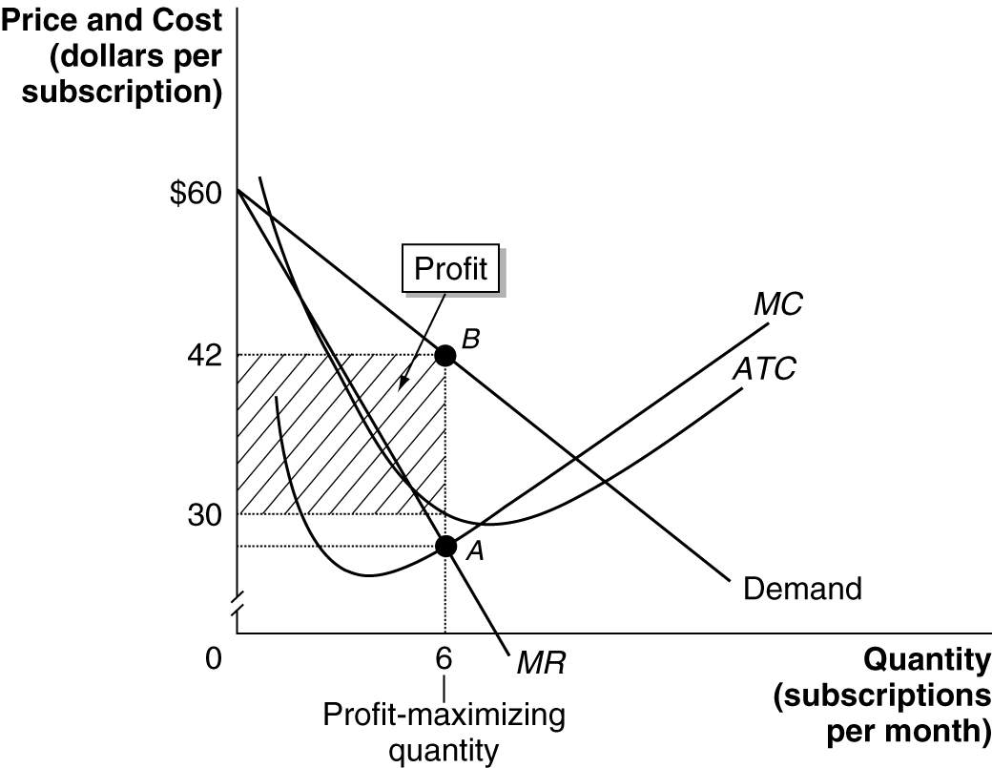

8. If a perfectly competitive industry is monopolized, the price will rise and the quantity produced will fall. Consumer surplus will fall, producer surplus will rise and a deadweight loss will arise. Figure 14-5 shows this.

9. Market power allows a firm to set its price above marginal cost, which creates deadweight loss. Research suggests that in the United States total deadweight loss from market power is fairly small – less than one percent of GDP.

10. The avowed purpose of antitrust laws is to eliminate collusion and promote competition among firms. The Department of Justice’s Antitrust Division and the Federal Trade Commission enforce these laws.

11. A horizontal merger is between firms in the same industry, while a vertical merger joins firms at different stages of production of a good. Horizontal mergers are more likely to increase the market power of the newly merged firm.

12. Charging a price equal to marginal cost means that output will equal the level at which marginal cost equals marginal benefit, which is the efficient point. However, charging this price would mean that the natural monopoly would earn a negative profit. If the regulator sets price to equal average cost instead, some efficiency will be lost but the natural monopoly will stay in business and earn a normal economic profit.

Answers to End of Chapter Problems and Applications

1. Monopoly is a pretty good name for the game Monopoly. The object of the game is to become the only owner of property, and, like a real market, once you have ownership of a set of properties you are able to increase the price. Consider what happens when someone rolls a 10 and lands on your hotel on Boardwalk. They are required to rent the property; there is no substitute, they cannot go anywhere else, you have a monopoly. An alternative version of Monopoly would be to roll the dice and then have the choice of going forward or backward. Now the player who rolls the 10 could go forward to your hotel on Boardwalk or backward to a cheaper property (New York). This ability to rent a substitute would substantially reduce the quantity of visits to your high-priced property, wiping out much of your monopoly profits. (I’ve played this version with my kids; no one ends up gaining all the property and no one is driven into bankruptcy.)

2. The USPS is probably not a natural monopoly. If it were, it wouldn’t need a law banning competition. It would be able to produce at a lower cost and charge a lower price than potential competitors, so no one would want to enter the industry. If the current law banning competitors were removed, firms would likely enter this market. They have already entered portions of the market (such as package and overnight letter delivery) where competition isn’t banned and seem eager to expand into additional sectors in the mail delivery business.

3. Even though local cable TV companies have a monopoly in providing cable service in a city, they face growing competition from satellite TV companies like DIRECTV and Dish Network. If consumers view satellite TV as a close substitute for cable TV, then the cable companies no longer have a monopoly.

4. Extending the life of pharmaceutical companies’ patents would allow them to charge the monopoly price for their drugs for a longer period and earn higher profits. This potential for higher profits would encourage them to develop more new products. Consumers would gain from having a wider range or medicines, but they would lose because their prices would stay high longer.

5. Book prices are higher than they would be without copyrights. If any publisher could print copies of John Grisham’s latest novel, competition would drive down the price. In this sense, copyright is a tax on readers. Because publishers cannot print copies of an author’s book without the author’s permission, publishers pay authors much more than they would if there were no copyrights. In effect, copyright gives an author a monopoly on any books the author writes. If copyrights were abolished, very few authors would be able earn a living by writing. As a result, many fewer books would be written, which would make readers worse off.

6. You are likely to make a loss. If a profit was likely in this market, someone would probably have already entered it.

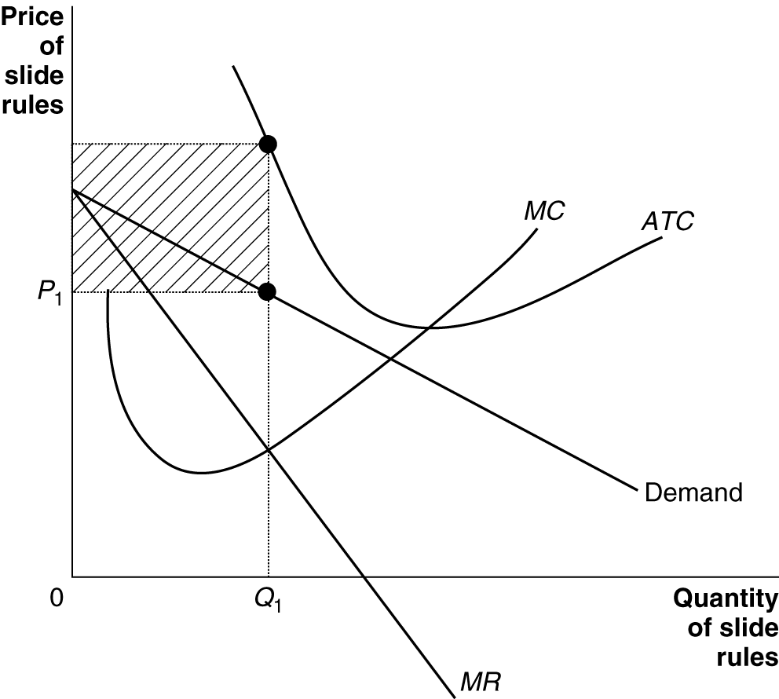

7. Yes, certain prescription drugs, for example. Economists generally define a monopoly as a firm that is the only seller of a good or service that does not have a close substitute. So, it is possible to have a monopoly on a product that has substitutes, as long as they are not close substitutes.

8. There are only a limited number of countries in the world, which limits the number of customers in this market. Also, printing currency that is difficult to counterfeit requires specialized printing methods.

9. Here is the definition of the supply curve from Chapter 3: “A curve that shows the relationship between the price of a product and the quantity of the product supplied.” A perfect competitor has a supply curve because it always equates price to marginal cost. Therefore, there is always just one price for every level of output. Because a monopolist equates marginal revenue to marginal cost, with marginal revenue being less than price, it is possible for there to be different prices for the same level of output. Therefore, a monopolist does not have a supply curve.

10a. The monopoly will produce 50 units and charge a price of $10.

10b. To achieve allocative efficiency, the regulatory agency should require the monopoly to charge a price equal to marginal cost, which in this case would be a price of $7. The regulated monopoly will produce 90 units. It will make a profit, because price is above average total cost.

11a. The monopoly will produce 20 units and charge a price of $30.

11b. Its marginal revenue curve is now a flat line at $18, running from the vertical axis to the demand curve, so the monopoly will produce 33 units and charge a price of $18. The quantity demanded at a price of $18 is 40, but the quantity supplied is only 33, so there will be a shortage of 7 units and some consumers will not be able to buy the product.

12. We can calculate average total cost at every quantity.

Quantity  (per day)  (Q) | Total Cost  (TC) | Average Total Cost  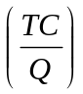
30 | $1,200 | $40
40 | 1,400 | 35
50 | 2,250 | 45
60 | 3,000 | 50
In order for the firm to have a natural monopoly, it must be able to produce at a lower average total cost than two firms. This is not the case here, because the firm’s average total cost begins to increase after it has produced 40 units per day.

13a.
Price | Quantity  (per week) | Revenue | Marginal Revenue | Total Cost | Marginal Cost
$20 | 15,000 | $300,000 | — | $330,000 | —
19 | 20,000 | 380,000 | $16 | 365,000 | $7
18 | 25,000 | 450,000 | 14 | 405,000 | 8
17 | 30,000 | 510,000 | 12 | 450,000 | 9
16 | 35,000 | 560,000 | 10 | 500,000 | 10
15 | 40,000 | 600,000 | 8 | 555,000 | 11

13b. Ed should charge $16 per baseball and produce 35,000 baseballs per week. His weekly profits will be $560,000 – $500,000 = $60,000.

13c. Because the tax does not affect his marginal revenue or marginal cost, Ed should not change the price he charges or the quantity he produces. His profits will fall by the amount of the tax, from $60,000 to $10,000.

14a. In the short run Comcast will continue to sell 6 subscriptions at $14 each. Its revenue = $84, but its cost is now $80 + $6, so its loss is $2. If this loss continues, in the long-run Comcast exit the market.

14b. The new tax increases the marginal cost by $0.50 per subscriber, as shown in the table:

Price | Quantity | Total Revenue | Marginal Revenue  (MR = ΔTR/ΔQ) | Total Cost | Marginal Cost  (MC = ΔTC/ΔQ)
$17 | 3 | $51 | – | $57.50 | –
16 | 4 | 64 | $13 | 65.00 | $7.50
15 | 5 | 75 | 11 | 73.50 | 8.50
14 | 6 | 84 | 9 | 83.00 | 9.50
13 | 7 | 91 | 7 | 93.50 | 10.50
12 | 8 | 96 | 5 | 105.00 | 11.50
Now Comcast will sell 5 subscriptions. It will charge a price of $15 per month, and earn profits of $75 – $73.50 = $1.50.

15. The argument is incorrect. As the graph shows, a reduction in marginal cost will cause a monopolist to reduce his price.

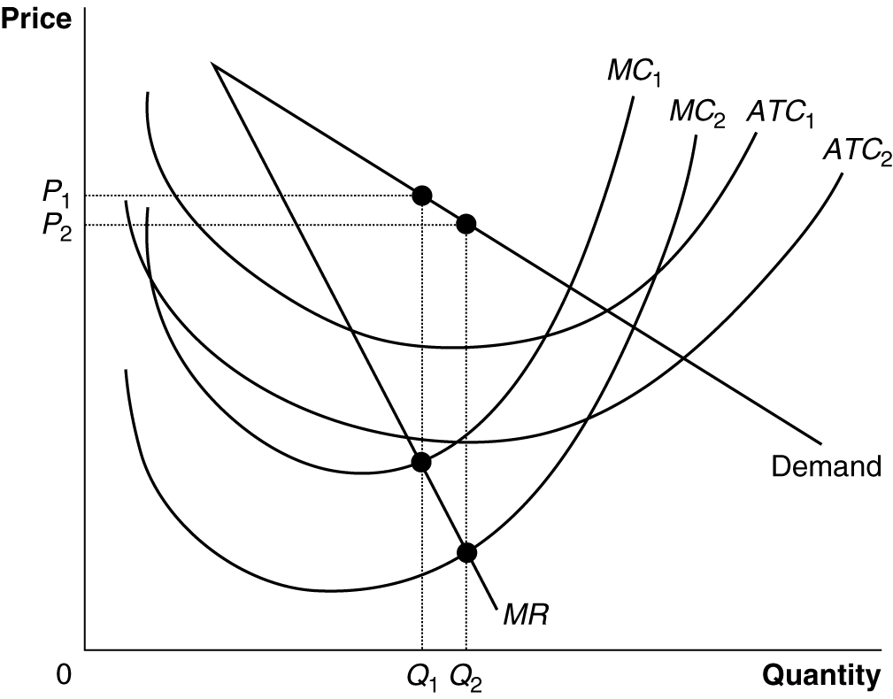

16. The statement is incorrect. The monopolist charges the price that allows him to sell the level of output where marginal revenue equals marginal cost. He is able to charge a higher price, but would not be maximizing profit if he did.

17. When a monopoly exists it doesn’t set the price whimsically, rather it sets the price so that consumers will buy the amount at which marginal cost equals marginal revenue. It is doubtful that a company in this situation would charge a price as high as $500 per month, because doing so would reduce the quantity demanded immensely and profit would be less than if a lower price were set.

18. No, to maximize revenue or production, the monopolist would have to charge a price that is lower than the profit-maximizing price.

19. If the monopoly were more efficient, its marginal costs would fall – from MC₁ to MC₂ in the figure. As the figure shows, if a monopoly has higher costs (MC₁) because it does not face competition, then the true deadweight loss is increased. The red-shaded area shows the original deadweight loss as it was in Figure 14-5. The black shading shows the additional deadweight loss from taking into account x-inefficiency – that is from the firm not producing more efficiently, at MC₂.

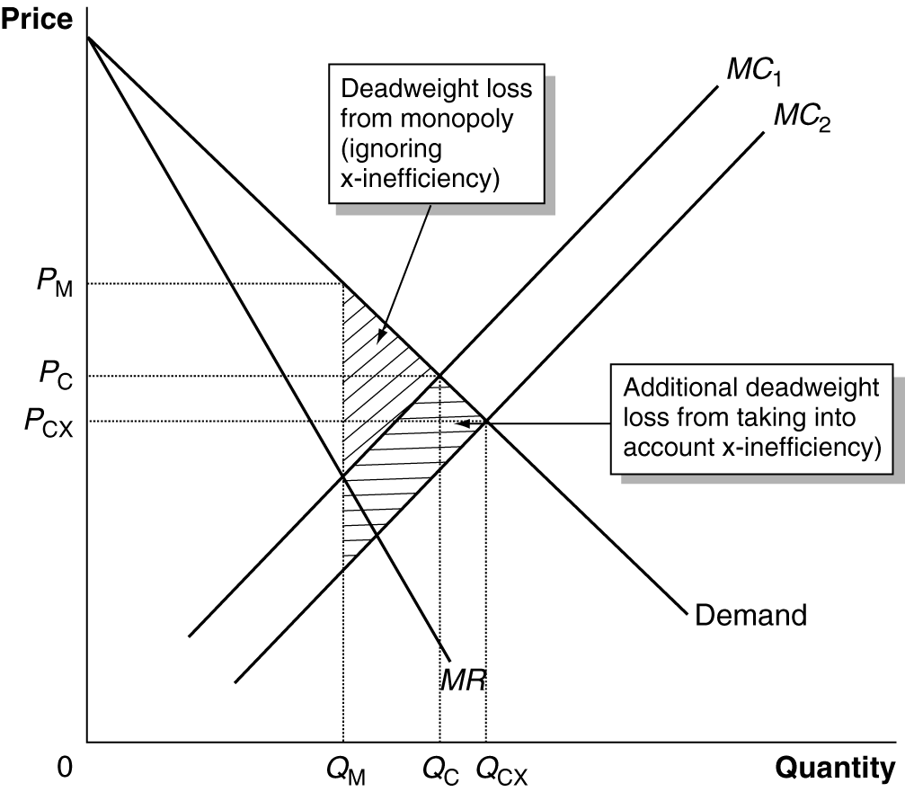

20. Under federal law, the Antitrust Division of the Department of Justice is given the responsibility of policing mergers to make sure that they don’t substantially reduce competition. If two large airlines merge, there will be less competition in the airline industry, which will result in higher ticket prices.

21. The Sherman Antitrust Act states that “every person who shall monopolize, or attempt to monopolize, or combine or conspire with any other person or persons, to monopolize any part of the trade or commerce … shall be deemed guilty of a felony….” Executives who conspire with executives in competing companies to set prices can be sent to jail, since this behavior constitutes a felony.

22.

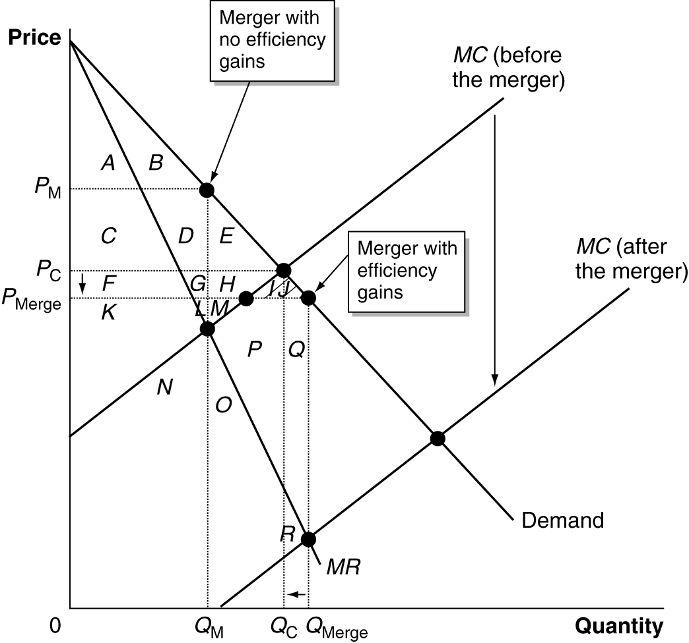

Before the merger the price was Pc and the quantity was Qc, so consumer surplus equaled A + B + C + D + E and producer surplus was area F + G + H + K + L + M. After the merger, price fell to P_{merge} and quantity rose to Q_{merge}, so consumer surplus equaled A + B + C + D + E + F + G + H + I + J and producer surplus became area K + L + M + N + O + P + Q + R.

23. Putnam understood that the antitrust laws do not allow firms in the same industry to agree on what prices they will charge.

24a. We need to calculate the Herfindahl-Hirschman Index (HHI). Before the merger: 20 x 5² = 500. After the merger: (15 x 5²) + 20² = 375 + 400 = 775. Because the post-merger HHI is below 1,000 the merger will not be opposed.

24b. HHI before the merger: 5 x 20² = 2,000. After the merger: (3 x 20²) + 40² = 1200 + 1600 = 2,800. Both before and after the merger, the HHI is above 1,800 so the merger will be opposed.

25. HHI before the merger: 29² + 22² + 21² + 17² + 8² + 3(1²) = 2,122. The HHI before the merger is already above 1,800 and the merger would increase the HHI, so the Department of Justice and Federal Trade Commission opposed the merger. After the merger, the HHI would have been: 50² + 22² + 17² = 8² + 3 (1²) = 3340.

26. HHI before the merger, assuming 11 firms in the “other” category, each with a 1 percent share of the market: 37² + 35² + 17² + 11(1²) = 2,894. So, even if no company other than Coca-Cola, Pepsi-Cola, and Cadbury Schweppes has a market share greater than 1 percent, the Department of Justice and the Federal Trade Commission would be likely to oppose a merger between two of the leading three firms.

27. Charging by the gallon is more likely to achieve allocative efficiency – as long as the price equals the marginal cost. In order to charge by the gallon, the city has to install a water meter in each firm or home and employ meter readers to gather information on how many gallons have been used. Some cities might want to avoid this expense.

28. The figure as drawn shows a monopoly producing the efficient level of output. Using different demand curves (and different sizes for the negative externality), it is possible to show that a monopoly may also produce an inefficiently high or low level of output in the presence of a negative externality.

